After Action Report – Tanker Wars

The backdrop to this scenario is that a British oil tanker, the British Heritage, was seized south of the Straits of Hormuz by masked men on 12th August 2019. Five British crew, including the captain and ships chief engineer, were taken off the vessel to a location unknown. The remaining crew were instructed to take the vessel and steer for Bandar Abbas in southern Iran. Throughout the week the participants in the scenario received secret daily briefings on the strengths of their forces, their objectives and other snippets of intel. An additional two hostages arrive during he week, brought by Houthis militia. How could they know where to bring these additional hostages? Was there a leak? The ruleset used was Force on Force from Ambush Alley with 20mm figures.
In the early hours of Friday 16th August, a patrol of Basji militia were beginning their patrol around the small fishing village outside Jabid from their barracks. Dotted around the village were Houthis militia, sound asleep including the roof top guards with their LMG’s.
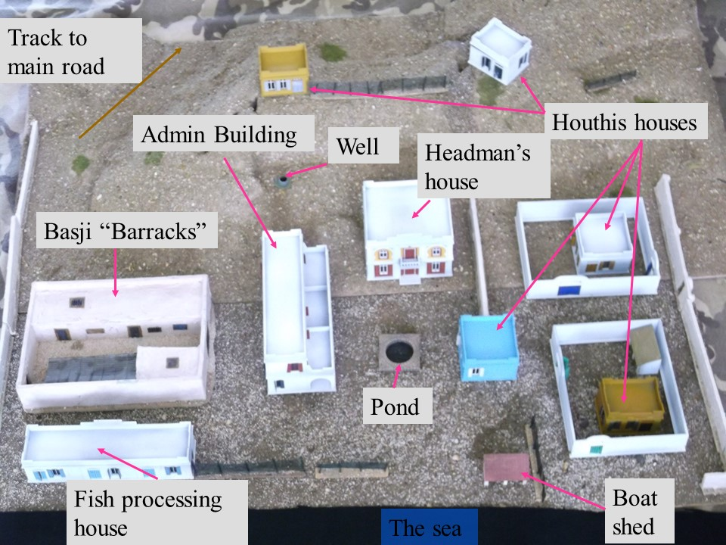
Figure 1 The sleepy fishing village near Jabid
Unbeknownst to the Basji patrol, 3 squads from the British Special Boat Service slipped ashore. The 1st squad with the SBS leader (acaptain who shall remain nameless!) headed for the admin building, the 2nd squad headed for the hostages, held in the Headman’s house. The 3rd squad headed for the blue Houthis house, Figure 2.
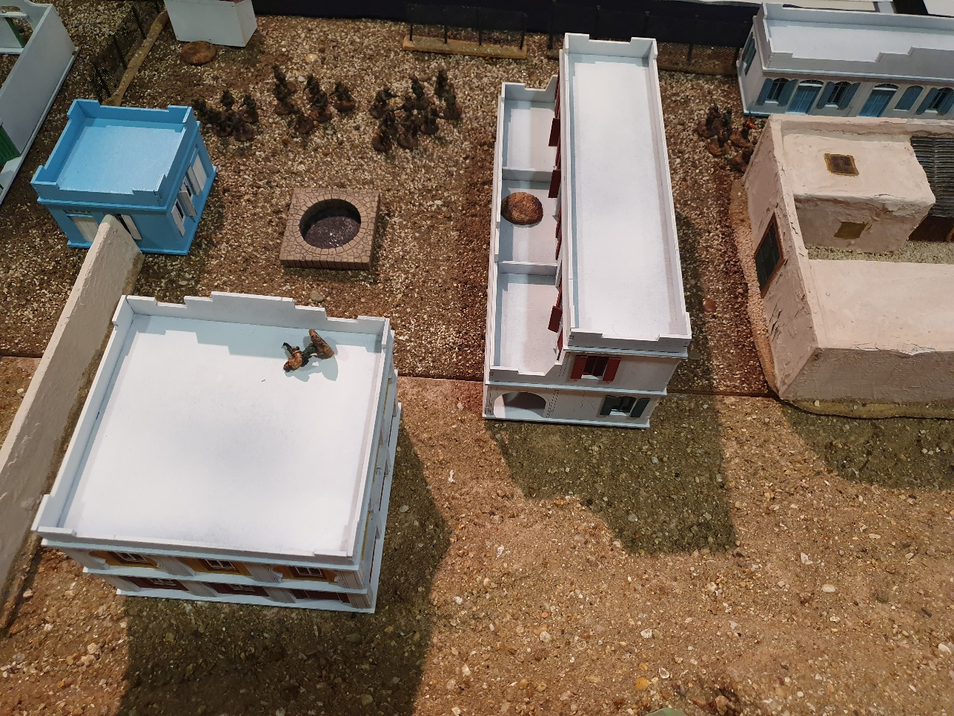
Figure 2 SBS sneak ashore, hidden from the Basji patrol by the Admin building
Unbeknownst to the SBS squads was the arrival of forces of unknown origin to the rear of the Headman’s house, Figure 3.

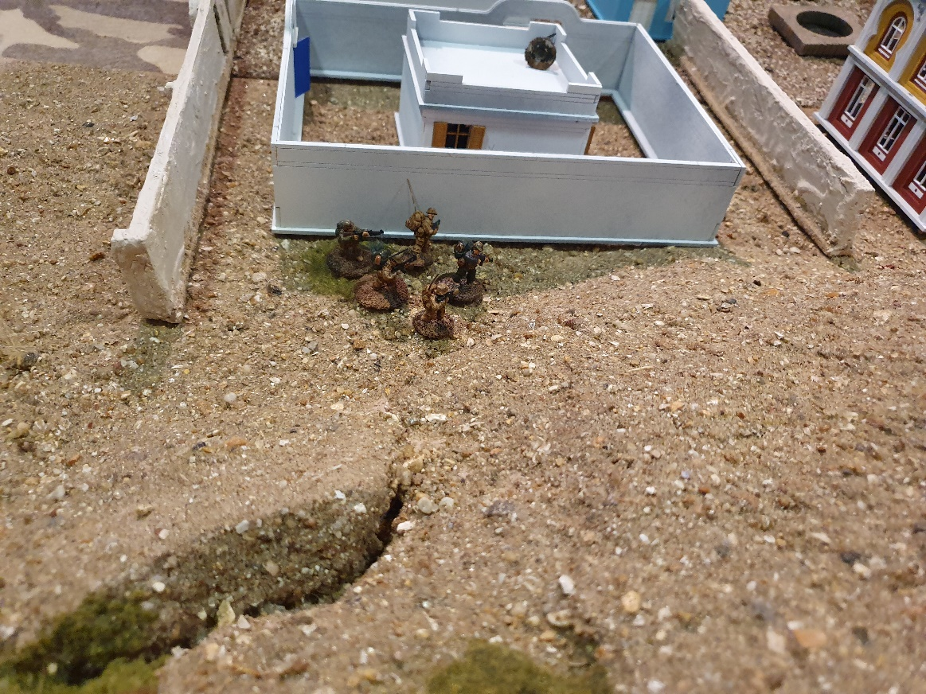
Figure 3 Unknown forces approach the rear of the Headman's house
The 1st SBS squad move to the wall of the admin building and start to set their breaching charge. However, the SBS captain rolls a 1 on their Troop Quality (TQ) roll, a Fog of War card is taken. Suddenly, there is bleating of goats and the barking of a single scrawny looking dog, the alarm is raised and the Basji and Houthis militia awake with a start. The SBS captain mutters an “Oh F**k”, Figure 4. The lone Basji LMG gunner on the roof, rudely awakened, interrupt the SBS squads to unleash a hail of bullets from his RPK, but to no effect, setting the tone for the early fire fights from the militia.
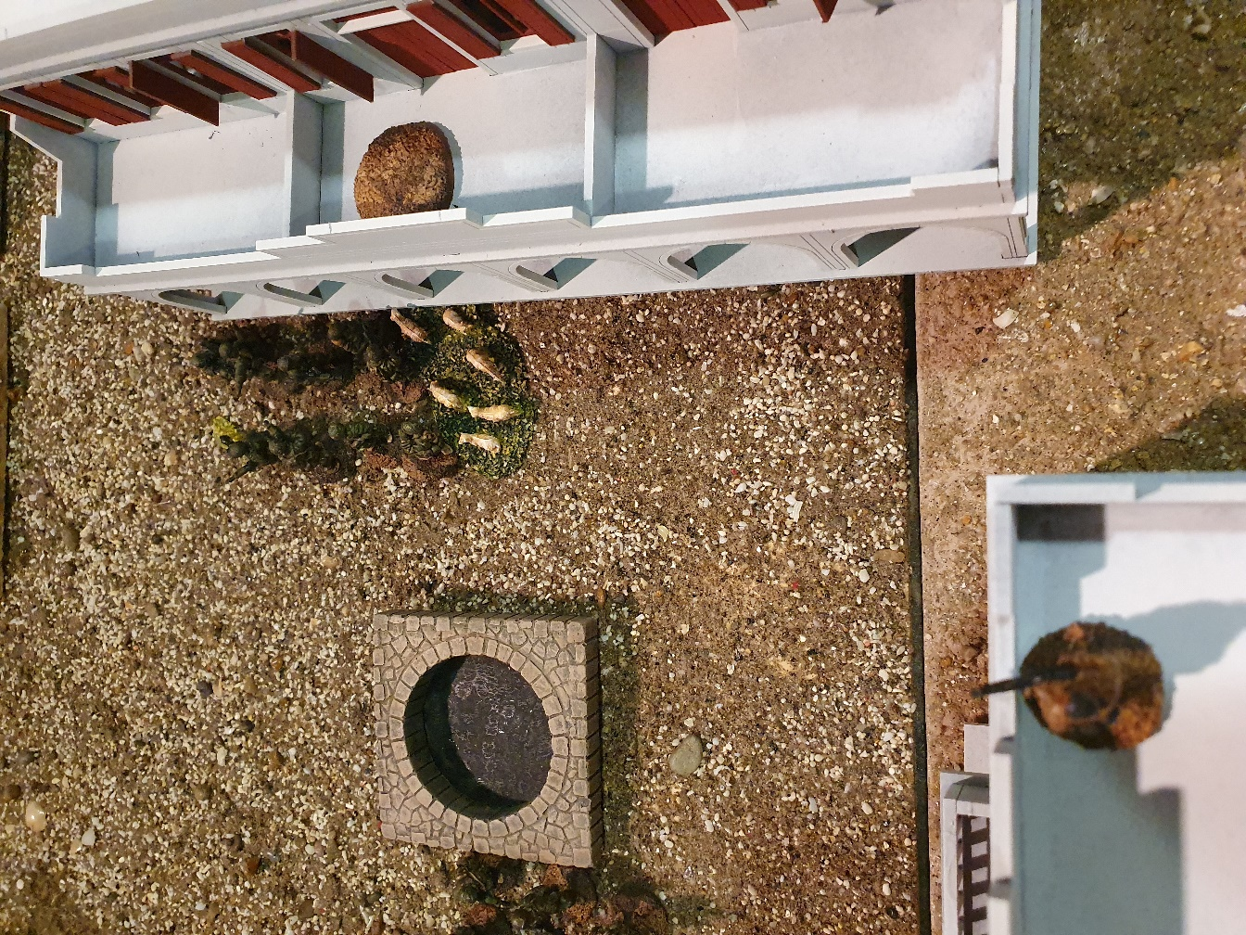
Figure 4 The goats are disturbed...
The remaining Basji militia begin to stumble into the barracks courtyard and form up. The 2nd SBS squad dashes towards the Headman’s house and prepares to breach it. The 3rd SBS squad occupies the blue Houthis house ready to provide covering fire only to find it full of Yemeni women screeching at the startled British troops. It all appears to be going wrong for the rescue operation as an Iranian Republican Guard Corps (IRGC) Colonel arrives in his SUV and tries to contact IRGC reinforcements. In the meantime, the unknown force contacted the rear of the Headman’s house, watched by a bemused Houthis militia man resting on his RPM on the roof of the yellow Houthis house on the hill.
Whilst the ABS captain disengages from the herd of goats, the sergeant of the, uninterrupted, 2nd SBS squad sets and explodes their breaching charge at the front of the Headman’s house. This is rapidly followed by an explosion at the rear of the building as the unknown force are revealed to be US special forces. The bemused Houthis militia man now opens up with his RPM, but all hits are shaken off by the US forces. Inside the Headman’s house, Figure 5, it all kicks off with stun grenades, shouting and a swift fire fight between the Basji, guarding the hostages, and the SBS and US Forces leaves the all Basji wounded but not out. The SBS and US Forces squabble over the hostage, and fail to secure the Basji, who recover from their wounds and another fire fight breaks out, this time leaving all the Basji severely wounded and unable to react further. The SBS squad take the four British citizens and the US forces take the two US citizens, both forces eave the poor French NGO worker to his fate!

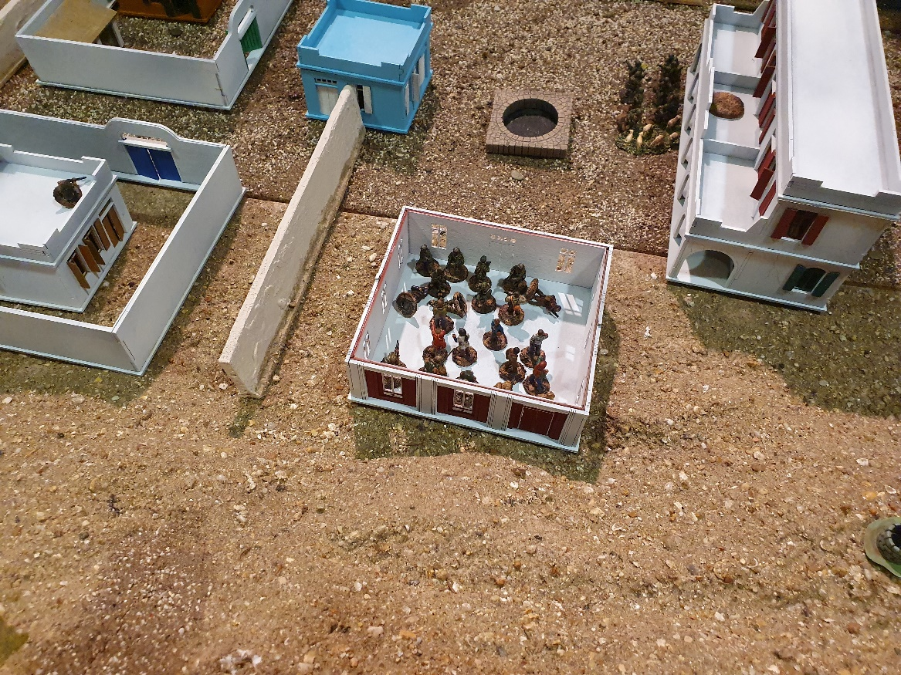
Figure 5 It all really kicks off in the Headman's house.
Exchanges of fire are held across the courtyard in front of the Headman’s house as the SBS squads attempt to withdraw towards their extraction point on the shore. The US forces, dragging their wounded machine gunner who took a RPG hit, made their withdrawal fairly unmolested as the Houthis and Basji militia concentrated their fire on the SBS squads, Figure 6.
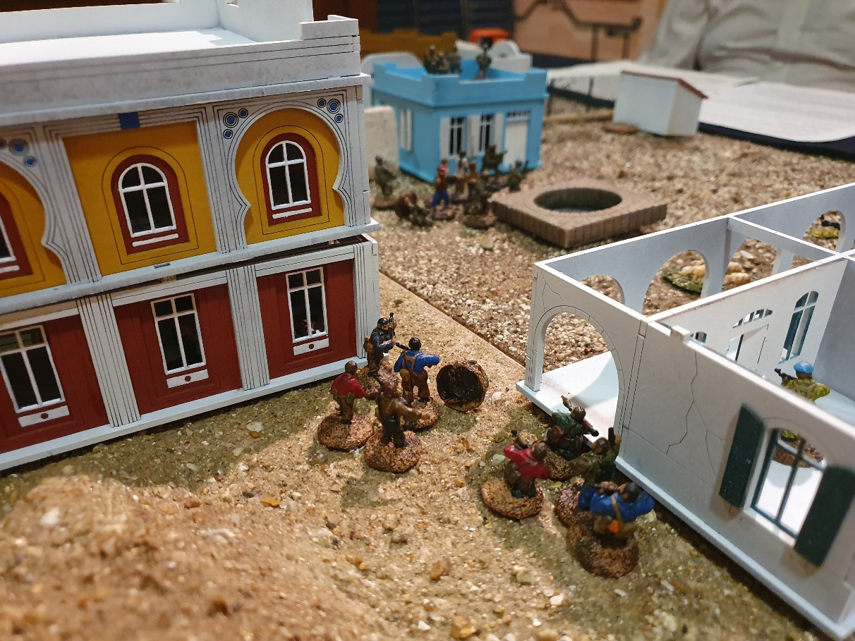
Figure 6 Basji militia concentrate fire on the SBS squad with the British Hostages
Alas, the Basji and Houthis militia’s effort were not enough. IRGC reinforcements failed to arrive as the colonel struggled with the comms equipment. Even the last-minute appearance of Iranian special forces on a fog of war card could not prevent the SBS squads withdrawing with their hostages.
However, the Basji and Houthis militia did inflict some dead and serious wounds on the SBS and US Forces. When taken individually, the militia forces won a marginal victory but, together the British and US won a decisive victory.

